**VODAFONE OVERVIEW**

Vodafone is one of top leading telecommunications and Internet services provider company. The company’s head operator located in UK. Today (Foye 2019). Vodafone has network in 25 countries and partner network 47 in other countries. In Australia, Vodafone was started to provide their service in 2009 (Foye 2019). However, since Vodafone started carriers in Australia, they have been competing with Telstra and Optus. Today, Vodafone is the third biggest market shared Telecom company in all across Australia .

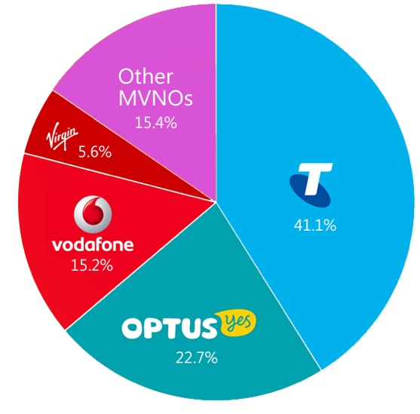

*Fig.1 Australian telecom market*

Vodafone provides following services includes mobile (Message, Call, Voice, Video call, and data), broadband, IoT, cloud services (database, security, and carrier service) (Foye 2019). Furthermore, Marketline (2019) stressed that company has a partnership with different industries such as health, utility service, automotive, manufacturing, fintech, banking and public transport etc. Today, Vodafone has approximately six million of active users and three hundred thousand broadband users.

Marketline (2019) stated that during the second half of 2019, Vodafone’s revenue dropped down by 1.7%, compare it to the past years' estimates it is a huge decrease. After that, the company implemented an AASB accounting standard but the revenue increased by 0.9% which is almost half of the losses (Marketline 2019). Unfortunately, company’s Net losses has been increasing since 2018.

Moreover, the Australian Vodafone headquarters is implementing a 5G network, cloud technologies, and Financial technologies and it will help Vodafone back into the business.

Vodafone has been focusing on IoT services since 2000. Globally, company has 76 million of IoT networks. Vodafone (2020) stated that for businesses, using Vodafone’s emerging technologies bring customer-based service, productivity service, low cost, data analytics system, trend analysis advantage (Foye 2019).

Under this topic, we will discuss Vodafone’s market, market competitors, competitive advantages, technologies they are implementing, Business model, and further analysis. We chose Vodafone because at the moment Vodafone invested in emerging technologies during the global financial crisis period.

**ORGANIZATIONAL BACKGROUND AND ANALYSIS**

Vodafone is a global telecommunications company that provides variety of services such as mobile all services, Internet broadband service, and emerging technologies services. Vodafone Hutchison Australia is a shared company with Hutchison Telecommunications Limited both companies own an equal amount of percentage. Vodafone Hutchison Australia has approximately 1500 employees, over 100 branches in all Australian cities. Strategically, Vodafone has partnerships from all over the world, and the company has a high demand for potential in cloud computing service, 5G network, cybersecurity systems. However, there are many unexpected and expected aspects affecting Vodafone's business growth including COVID-19, technology changes, security risks, competitors, policies, etc.

SWOT ANALYSIS

|  |  |
| --- | --- |
| **Strength**  Global partnerships  Branches from over 150 countries  Number of customers  User Database | **Weakness**  Revenue decreases  Big competitors in market |
| **Opportunity**  Cybersecurity service in market  IoT technology provider service  IT services  Cloud computing | **Threat**  Cybersecurity risks  Technology changes  Mobile termination reduces  Economic crisis |

**Strength**

Global Partnerships - Customers of Vodafone are provided the best services by partnership programs. Global Vodafone’s network partnerships Telecom Italia group and Orange from Spain involved to 4G extension and 5G network development. Furthermore, British Arm Holdings joined to the Internet of Things solutions development with Vodafone. It is a big project planning to connect IoT worldwide.

Number of Customers – There are total six about millions of people are using Vodafone and three hundred thousand of people are using broadband service in Australia. Worldwide, total 313 millions of users estimated in 2018.

Branches - Today, a total of 25 countries using Vodafone services, 41 countries partnership with Vodafone, and IP-VPN service with 74 countries.

User Database – Vodafone spends time and money on marketing campaigns based on the customers database. For the company, three hundred user databases are a big advantage.

**Weakness**

Revenue decrease - According to the last few years of statistics, Vodafone’s revenue has been decreasing. The number of customers is changing to other mobile operators continuously in Australian markets.

Big competitors in market - Biggest competitors are taking market from Vodafone. Also, small companies are rapidly increasing and sharing market.

**Opportunity**

Cybersecurity service in market - There are great opportunities in the cybersecurity field including network security system, organization’s security, data security, and cloud security, etc. And also, cloud-based data store business, data recovery service, identity, and access security, and database security services demand is increasing.

Internet of Things – For Vodafone, it is already implemented business but this market is never endless potential for tech companies. IoT, 5G and cloud technologies combination is the booming at the moment.

Cloud service – Vodafone has been providing cloud service for long time. For the it is not new but still needs to implement in every industry.

**Threat**

Vodafone depends on infrastructure and technologies that increase high risk of cyber-attacks. Every company that connects to the internet has facing cybersecurity problems such as cyber-attacks, viruses, vulnerabilities, data threats, exploit, etc. Implementing cybersecurity for big organizations as Vodafone is not that easy and it is a huge expense in every level of the company.

Technology changes are getting uncatchable faster than before. Especially, emerging technologies development requires speed and cost from companies.

Mobile operating service is a competitive business and termination of mobile depends on the competitors.

An unexpected situation such as COVID-19 itself has affected by the world economy. During this period, every company is getting lost.

**VODAFONE STRATEGY**

Vodafone clearly mentioned that company will work on the competitive advantage and returns enhancement. Vodafone has been trying to achieve enhanced customer data analytics, digital transformation, the current business model, and asset utilization. Under this achievement, the company is implementing sustainable business management, risk management, culture, and people. Vodafone stated that this strategy will lead to organic growth and business value in society. Furthermore, Vodafone implementing Business performance and strategic developments which includes:

* Vodafone's headquarter approved the revised strategy and refresh purpose.
* Vodafone finalized the company's integration of ideas.
* Vodafone proposed the acquisition of some European countries Liberty assets.
* Confirmed to improve competitive advantages
* Confirmed that long-term sustainability policy.

**Board leadership and company purpose**

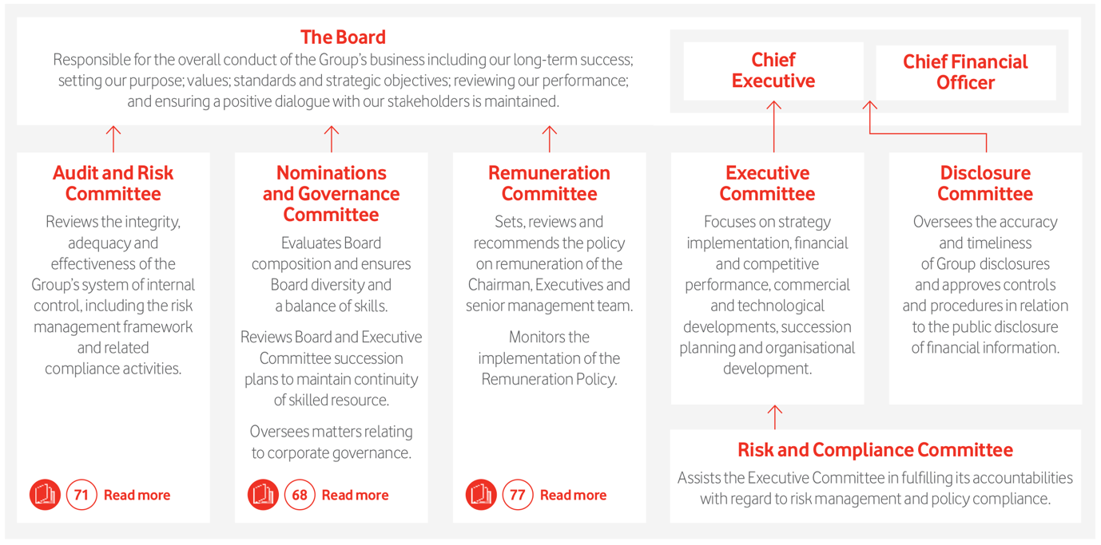

*Figure.2 Vodafone’ Leadership and responsibilities*

Vodafone uses Matrix organizational structure which enables reporting relationships are set up as a grid, or matrix. Using a matrix organization structure has following advantages

* Improves coordination across the organization
* The decentralized decision comes out immediately
* Improves communication between all layers
* Provides more multiskilled workers
* Employees skills are improved
* Improves the ability to access all the resources

Table.1 Vodafone business model canvas

|  |  |  |  |  |
| --- | --- | --- | --- | --- |
| Key Partners | Key activities | Value Propositions | Customer relationships | Customer segments |
| * Network partners * Developers * Sponsors * Advertisement partners * Product suppliers * Investors * Entertainment companies * Other telecom companies * Government * Acquisitions * Content providers * Distributors | * Innovation * Product development * Marketing * Customer-based service * Network maintenance and service * Transaction * Procurement * Content creates | * Cloud service * IoT * Tele communications service * Health services * Wholesale services * Roaming services * Online transaction services * Internet services | * Digital * Mobile * Social media * Vodafone all services * Quality * Brand awareness * Emerged technologies * User databases | * Mass market * Pre-paid customers * Post-paid customers * SME * Large corporates * Public sectors * Government * Overseas branches |
| Key resources | Channels |
| * 25 countries branch and 41 network partners * Global network in 150 countries * Huge amount of customer database * Infrastructure and coverage * IT investments its capabilities * Partners * Employees * Management * Marketing | * Branches * Website * Mobile apps * Shops * Distributors * TV * Social media * Partners * Call centres * Vodafone group foundation * Account management |
| Cost structure | | Revenue Streams | | |
| Networks  Data centre  Power supplies  Customer service  Copyrights  Licenses  Taxes  IT capabilities  Maintenance  Content acquisition  Compensation  Marketing  Advertisement  Event organisation | | Subscription fees  Service fees  Sales  Network connection fees  IT services fee | | |

According to Australia's telecom market, the report provided Key Performance Indicator's and subscribers database, revenue, and average revenue per user. Markets coverage included the biggest players in Australian telecommunication companies such as Optus, Telstra, TPG, Vodafone (Nagy 2019).

Table.2 Mobile services providers metrics.

|  |  |
| --- | --- |
| Fixed telecommunication market | Mobile telecoms market |
| Connections   * VoBB * Narrowband * Broadband * DSL cable modem * IPTV * Dial-up internet | Connections   * Mobile broadband * Prepaid and contract service * Population penetration for total * 2G/3G/4G * Handset(penetration) * Broadband(penetration) * M2M(penetration) |
| Traffic   * Fixed-originated minutes * Outgoing MoU | Traffic   * Mobile-originated minutes * Outgoing MoU per active connection * Mobile data * Total data per connection |
| Operator-level market share   * Broadband users | Operator-level market share   * Connections |
| Total telecoms market (fixed and mobile)   * Voice connections * Broadband network * Service revenue * Retail revenue * Retail revenue by voice and data * Originated minutes | |

From the above table, we noticed that it is possible to use Vodafone User data analytics on collected data. However, not all companies provide all these services.

**List of competitors**

* AGL
* Aussie Broadband
* Fetch TV
* Foxtel
* NBN
* Optus
* Superloop
* Telstra
* TPG
* Uniti Group
* Vocus

There are approximately 19 million people using a mobile phone and 41% Telstra, 23% Optus, 15% Vodafone, 5.5% Virgin, 15.5% others.

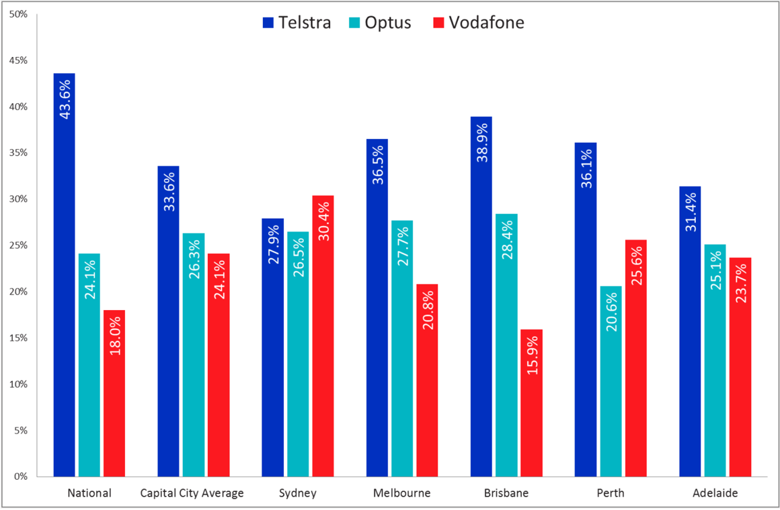

### *Fig.3 Mobile Provider Market Shares in Mainland Capital Cities*

**References:**

Foye, B 2019, *Vodafone Australia results “stable” in rough*, CRN, retrieved 30 April 2020, <https://www.crn.com.au/news/vodafone-australia-results-stable-in-rough-year-528871>

Marketline 2019, *Vodafone group Pic*, Marketline, retrieved 30 April 2020, <http://eds.b.ebscohost.com/eds/pdfviewer/pdfviewer?vid=1&sid=0ffba94d-b36c-420f-8e5f-f43b11c38d0a%40pdc-v-sessmgr03>

Nagy, W 2019, Australia telecoms market report, Knowledge centre, retrieved 1 May 2020, < https://www.analysysmason.com/Research/Content/Country-reports/Australia-country-report-RDRP0/>

Vodafone Group Plc, *Annual report 2019*, Vodafone, retrieved 1 May 2020, <https://www.vodafone.com/investors/investor-information/annual-report/downloads/Vodafone-governance-2019.pdf>

# Morgan, R 2017, *Why Vodafone is the top mobile provider in (only) Sydney,* ROYMORGAN, Vodafone, retrieved 1 May 2020, < http://www.roymorgan.com/findings/7151-mobile-phone-service-providers-market-shares-in-capital-cities-december-2016-201702171432>

**Images references:**

Kantar, 2016, *Australian Mobile Market Share*, Kantar retrieved 1 May 2020

<https://mobilenetworkguide.com.au/australian_mobile_carriers.html>

Vodafone Group Pic2019, *Vodafone’ Leadership and responsibilities,* Vodafone, retrieved 1 May 2020, <https://www.vodafone.com/investors/investor-information/annual-report/downloads/Vodafone-governance-2019.pdf>

### Morgan, R 2017, Mobile Provider Market Shares in Mainland Capital Cities: *Why Vodafone is the top mobile provider in (only) Sydney,* RoyMorgan, Vodafone, retrieved 1 May 2020, < http://www.roymorgan.com/findings/7151-mobile-phone-service-providers-market-shares-in-capital-cities-december-2016-201702171432>